PROCESS | START/DATE&TIME |  | ASSEMBLY BY | Short block
PROCESS | FINISH/DATE&TIME |  | ASSEMBLY BY | Main Line

Firiing Order |  | 1R-1L-5R-5L-3R-3L-6R-6L-2R-2L-4R-4L | All dimensions in millimetres
Valve Clereance | Intake | 0.35 ± 0.02 | All torques in Kilogram metres
Valve Clereance | Exhaust | 0.57 ± 0.02 | All torques in Kilogram metres

No. | PARTS | CHECK | CONDITIONS TO BE CHECKED |  |  |  |  | SPEC. | SIGN |  |  |  |  |  |  | SKETCH DRAWING or PHOTOES
 |  | POINT |  |  |  |  |  | SPEC. | MEC |  | QA |  |  | SPV |  | SKETCH DRAWING or PHOTOES
1 | Cylinder  Block | Bores | Check that the liner counter bore is clean |  |  |  |  |  |  |  |  |  |  |  |  | 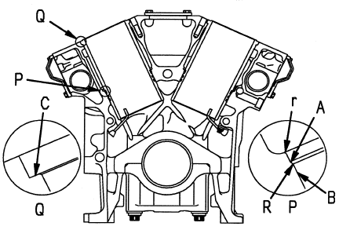
 | Cylinder  Block |  | and serviceable prior to fitting liner.
 |  | Inside of | Check that all oil holes are free from
 |  | oil hole | foreign matter such as chips or dirt.
 |  | U-plugs & | Make sure that all U-plugs and blind
 |  | blind plugs | plugs have been installed.
 |  |  | Make sure that Cyl. block condition is ready to used completely |  |  |  |  | - ~ 2.0 kgm  (Komatsu assembly manual)  THE OTHERS PLUG, SEE PLUG TABLE FOR TIGHTEN
 |  |  | - Tightening plug :
  Hexagon plug 5 mm | Act : kgm
• Oversize head gasket required:

Yes | No

 | 1 | S/N | Cylinder block S/N new:
 |  | S/N | Cylinder block S/N original:
 |  | Liner deck | See that three bondLG-6 has been applied to the proper area.
 |  | portion
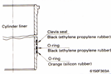  2 | Cylinder  Liner | Crevice  seal  O-rings | Check that the chamfered side is facing down. |  |  |  |  |  |  |  |  |  |  |  |  | 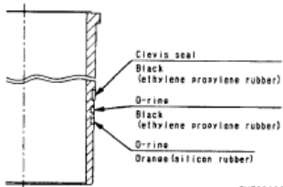  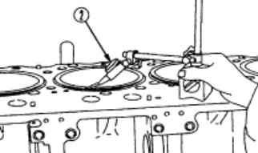
 | Cylinder  Liner |  | Check that the colour of the bottom O-ring is orange
 |  |  | Apply oil immediately before installing.
 |  |  | Set the “T” mark on the top surface of the liner facing the front.
 |  | Liner | Using a cloth, wipe off dirt and oil from contact surface
 |  |  | of liner lip and cylinder block counterbore.
 |  | Liner  Protrusion | Check the protrusion of the liner: |  |  |  |  | 0.10~0.15mm  (Shop Manual Page. 50-5)
 |  | Liner  Protrusion
  R bank
  L bank
3 | Crank shaft | Crank | Make sure that stamp mark on Crank Shaft is available. |  |  |  |  | STD or  US 0.25  US 0.50 |  |  |  |  |  |  |  | 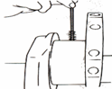  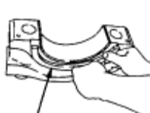  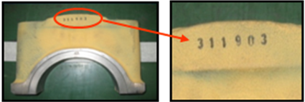
 | Crank shaft | Main | Check Code of Main metal,code are: STD/0.25/0.50  Code: |  |  |  |  | STD or  US 0.25  US 0.50
  STD | 0.25 | 0.50
 | Crank shaft | Bearings |  |  |  |  |  | STD or  US 0.25  US 0.50
 | Crank shaft |  | before tightening. Coat the inside face with  engine oil.  Do no coat the rear surface of the bearing  • Upper bearing has oil hole  • Lower bearing has no oil hole |  |  |  |  | STD or  US 0.25  US 0.50
2.7~3.4 mm
(Shop Manual Page. 50-5)
 |  | 1 | - Protrusion of Dowel Pin  *Make sure the number of main cap same  with S/N Engine Block.  CRANKSHAFT S/N:  (Serial No Engine at rear face of Crankshaft) |  |  |  |  | 2.7~3.4 mm  (Shop Manual Page. 50-5)
  Act : mm
No. | PARTS | CHECK | CONDITIONS TO BE CHECKED |  |  |  |  | SPEC. | SIGN |  |  |  |  |  |  | SKETCH DRAWING or PHOTOES
 |  | POINT |  |  |  |  |  | SPEC. | MEC |  |  | QA |  | SPV |  | SKETCH DRAWING or PHOTOES
 | Crank shaft  Cont. | Thrust  bearing | Install the thrust bearing with the groove  on the crankshaft side. |  |  |  |  |  |  |  |  |  |  |  |  | 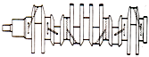
 | Crank shaft  Cont. | Thrust  bearing |  |  |  |  |  |  |  |  |  |  |  |  |  | 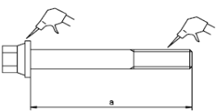  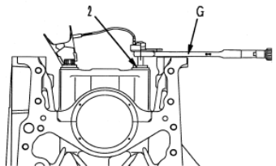  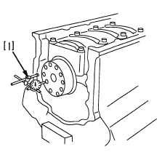
 | Crank shaft  Cont. |  | Bolts must be oiled. When tightening,  start from the center and work in order to the Outside |  |  |  |  | Less than 176.3 mm (Shop Manual Page. 50-6)
 | Crank shaft  Cont. | Torque of  Bearing  Cap |  |  |  |  |  | Less than 176.3 mm (Shop Manual Page. 50-6)
 | Crank shaft  Cont. | Torque of  Bearing  Cap | Using limit length (a) of bolt stem: |  |  |  |  | Less than 176.3 mm (Shop Manual Page. 50-6)
 | Crank shaft  Cont. |  | 1st step : Act : kgm |  |  |  |  | 29 ± 1.5 Kgm
 | Crank shaft  Cont. |  | 2nd step: Act : kgm |  |  |  |  | 58 ± 1.0 Kgm
 | Crank shaft  Cont. |  | 3rd step : Act : ⁰ |  |  |  |  | 90 ~120 ⁰  (Shop Manual Page. 50-7)
 | Crank shaft  Cont. |  | * After tightening bolt, make 1 punch mark  on the head of each bolt. (Don’t make a  punch mark when using a new bolt)  * Punch mark max. 5 punch marks.
 | Crank shaft  Cont. | Seal | Clean of all dirt and dust on the contact surface of the front and rear seals
 | Crank shaft  Cont. | Surface
 | Crank shaft  Cont. |  | Measure crankshaft End Play with dial gauge
 | Crank shaft  Cont. | End Play | Act : mm |  |  | • Tolerance: |  | 0.140 -0.320 mm  (Shop Manual Page. 50-7)
 | Crank shaft  Cont. |  | Check that shaft turns smoothly  • Standard rotating force:
 | Crank shaft  Cont. |  |  | Act : kgm |  |  |  | 1.5 Kgm  (Shop Manual Page. 50-7)
 |  | Radial out & Face Runout Crankshaft | Measure Face & Radial out of Crankshaft at Front and Rear surface Crankshaft before install Con rod assembly. |  |  |  |  | Maximum 0.05 mm  (std aligment main bearing bore)
 | 1 | Radial out & Face Runout Crankshaft |  |  |  |  |  | Maximum 0.05 mm  (std aligment main bearing bore) |  |  |  |  |  |  |  | Front Face Runout: mm
 |  | Radial out & Face Runout Crankshaft |  |  |  |  |  | Maximum 0.05 mm  (std aligment main bearing bore) |  |  |  |  |  |  |  | Front Radial out: mm
 |  | Radial out & Face Runout Crankshaft |  |  |  |  |  | Maximum 0.05 mm  (std aligment main bearing bore) |  |  |  |  |  |  |  | Rear Face Runout: mm  Rear Radial out: mm
4 | Piston and  Con. rods | Piston | When assembling a new connecting rod,  mark the cylinder number with an electric punch. Do not make a stamped mark. |  |  |  |  |  |  |  |  |  |  |  |  | 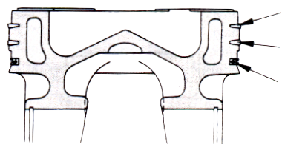  Top  2nd  Oil
4 | Piston and  Con. rods | Piston | Set up each ring with the stamped mark facing up. Note the position of the ring gap. |  |  |  |  | top ring: 1RS second ring: 2RX
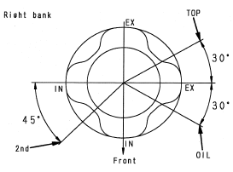
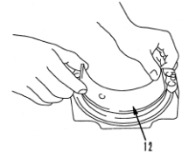

4 | Piston and  Con. rods | Piston | For the oil ring, take out the expander and install it into the piston, then install the oil ring.
4 | Piston and  Con. rods | Piston | Confirm that the expander is properly fitted to the groove.
4 | Piston and  Con. rods | Snap | Assemble piston and connecting rod.
4 | Piston and  Con. rods | Ring | Confirm that the snap ring which secures  the piston pin is properly fitted to the grove.  Check that the connecting rod moves smoothly  -Check size of Pin metal and recheck Code Pin metal on rear surface of metal.(Code of Pin Metal are:STD/0.25/0.50).  Code of Pin metal:
  STD | 0.25 | 0.50
4 | Piston and  Con. rods | Conrod Bearing
4 | Piston and  Con. rods | 1
 | Piston and  Con. rods |  |  |  |  |  |  | STD or  US 0.25  US 0.50
No. | PARTS | CHECK | CONDITIONS TO BE CHECKED |  |  |  |  | SPEC. | SIGN |  |  |  |  |  |  | SKETCH DRAWING or PHOTOES
 |  | POINT |  |  |  |  |  | SPEC. | MEC |  |  | QA |  |  | SPV | SKETCH DRAWING or PHOTOES
 | Piston and  Con. rods cont. | Con. rod  Bearing | Match the number of con. Rod are aligned Check that there is no dirt at the rear face of |  |  |  |  |  |  |  |  |  |  |  |  | 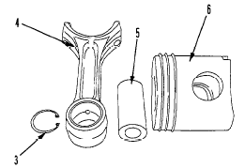  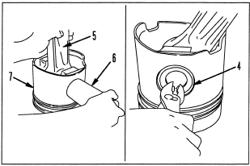  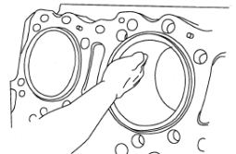  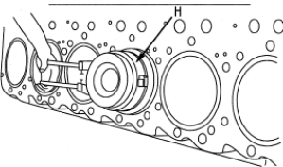  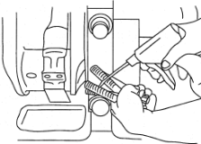  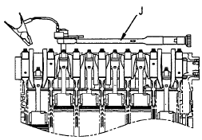  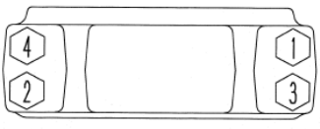  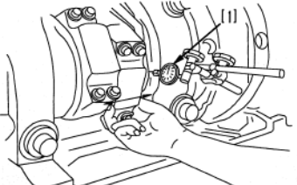
 | Piston and  Con. rods cont. |  | the bearing before assembling.
  CYL | 1 | 2 | 3 | 4 | 5 | 6
  UP
  LOW
 | Piston and  Con. rods cont. |  | Do not coat the rear surface bearing with oil.
 | Piston and  Con. rods cont. | Inserting  Piston &  Con. Rod | Check that the hole in the upper bearing and the oil hole in the co. rod are aligned.  Set the cylinder block on its side so that the assembly does not enter the cylinder suddenly when inserted.
 | Piston and  Con. rods cont. | Inserting  Piston &  Con. Rod | Coat the cylinder liner with engine oil (SAE 15W-40)  uniformly around the whole circumference by Hand.
Check that number of piston and connecting
rod assembly match cylinder number.
 |  |  | Coat connecting rod lower bearing with engine oil, spreading over whole part with finger.
 |  |  | Con rod bolts are to have oil (SAE15W-40) on the threads and under the washers.
 |  | Big End | 1st step: Act : kgm |  |  |  |  | 7 ~ 8 kgm
 |  |  | 2nd step: Act : kgm |  |  |  |  | 7 ~ 8 kgm
 |  | Torque | 3rd step: Act : ° |  |  |  |  | 90⁰ ~ 120⁰
 |  |  |  |  |  |  |  | (Shop Manual Page. 50-11)
 |  |  | After tighten of bolt, make 1 punch mark on
 |  |  | the head of each bolt (Don’t make a punch
 |  |  | mark when using a new bolt)
 |  |  | * Punch mark max. 5 punch marks.
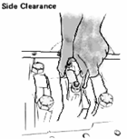
 |  |  | Measure con rod side clearance
0.300 ~ 0.454
mm
(Shop Manual Page. 50-11)

  CYL | 1 | 2 | 3 | 4 | 5 | 6
No. | PARTS | CHECK | CONDITIONS TO BE CHECKED |  |  |  |  | SPEC. | SIGN |  |  |  |  |  |  | SKETCH DRAWING or PHOTOES
No. | PARTS | POINT |  |  |  |  |  | SPEC. | MEC | QA |  |  | SPV |  |  | SKETCH DRAWING or PHOTOES
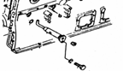 | Piston and  Con. rods cont. |  | Recheck/pastikan bahwa posisi piston sudah benar (dilihat dari posisi top).  * Cowakan yang lebih dalam ada di sisi intake  * Cowakan yang dangkal ada di sisi exhaust |  |  |  |  |  |  |  |  |  |  |  |  | 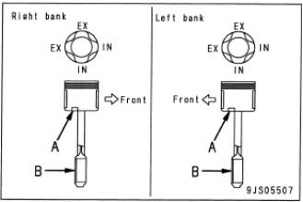  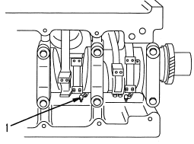
  CYL | 1 | 2 | 3 | 4 | 5 | 6
  RH
  LH
 | Piston and  Con. rods cont. |  | Check that the piston cooling nozzle is not clogged and that the angle is correct and Install to Block.  Tightening torque
  Act : kgm
 | Piston and  Con. rods cont. | Piston Cooling  Nozzle |  |  |  |  |  | 5.5 ± 2.0 Kgm  (Shop manual Page. 50-11)
5 | Timing Gear Case |  | - Prior to installation, fix several portions on gasket temporarily using the gasket sealant so that it may be displaced. |  |  |  |  |  |  |  |  |  |  |  |  | 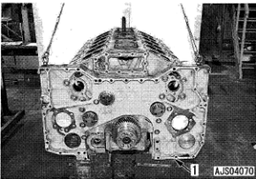
6 | Camshaft |  | - Turn the cam gear and tighten the mounting bolt, through lightening hole.  * Replace the current mounting bolts with a new one |  |  |  |  |  |  |  |  |  |  |  |  | 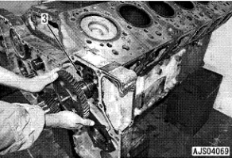
 |  |  | - Cam shaft mounting bolt : |  |  |  |  | 9.0 ± 3.5 Kgm (Shop Manual page. 50-12)
  Act : kgm
7 | Idler  gears | Idler gear  (small) | - When install idler gear, align the counter mark” D” to that the cam gear for the right bank.  - Coat the idler gear bushing inner surface with engine oil (15W40).  - Install plate (1) and tighten mounting bolts.  - Tightening torque : |  |  |  |  | 10.0 ~ 12.5 kgm  ( Shop Manual Page. 50-14) |  |  |  |  |  |  |  | 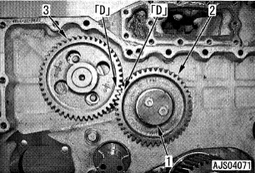
  Act : kgm
 |  | Torque Bolt
 |  | Supply pump gear  Torque Nut | - Install key (2) to the shaft  - Install supply pump gear and tighten  mounting nut.  *Coat on thread of shaft supply pump use adesive Locktite LT2(High strength type)  - Tightening torque mounting nut : |  |  |  |  | 18 ~ 20 kgm  ( Shop Manual Page. 50-14) |  |  |  |  |  |  |  | 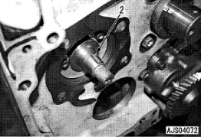  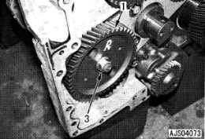
  Act : kgm
No. | PARTS | CHECK | CONDITIONS TO BE CHECKED |  |  |  |  | SPEC. | SIGN |  |  |  |  |  |  | SKETCH DRAWING or PHOTOES
No. | PARTS | POINT |  |  |  |  |  | SPEC. | MEC | QA |  |  | SPV |  |  | SKETCH DRAWING or PHOTOES
7 | Idler  Gears  Cont. | Idler gear  (large) | - Set the No.1 cylinder head on the right bank to the top dead center position.  - Coat the idler gear bushing inner surface with engine oil (15W40).  - Install trust plate (4) to the shaft.  - Install idler gear (2) and (3), then tighten mounting bolts.  - Tightening torque mounting bolts :  *Install gear such the counter marks as well as that of respective gear may come to the positions shown on the figure. |  |  |  |  | 10.0 ~ 12.5 kgm  ( Shop Manual Page. 50-15) |  |  |  |  |  |  |  | 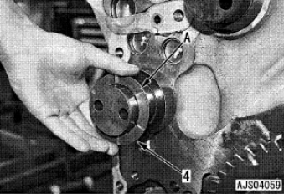  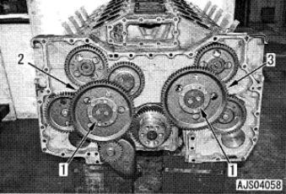
  Act : kgm
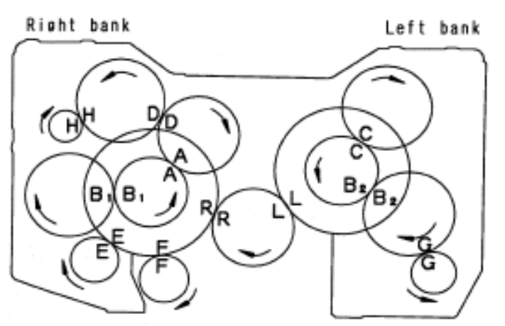

Timing Gear Marked |  | Check Point |  | Backlash (mm) |  |  |  | SIGN |  |  | SKETCH DRAWING or PHOTOES
 |  |  |  | Standard | Measured |  |  | MEC | QA | SPV | SKETCH DRAWING or PHOTOES
A • A |  | Right idler gear (small) and right sub idler gear. |  | 0.130 ~ 0.390  (0.125 ~ 0.363) |  |  |  |  |  |  | Note :  The standard value  enclosed in ( ) indicates  the backlash between  “ spur gears”  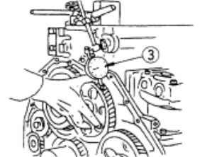
B1 • B1 |  | Right sub idler and right supply pump gear. |  | 0.051 ~ 0.469  (0.125 ~ 0.363)
B2 • B2 |  | Left sub idler and right supply pump gear. |  | 0.051 ~ 0.469  (0.125 ~ 0.363)
C • C |  | Left sub idler gear and left cam gear |  | 0.129 ~ 0.391  (0.125 ~ 0.363)
D • D |  | Right idler gear (small) and right cam gear. |  | 0.129 ~ 0.391  (0.125 ~ 0.363)
E • E |  | Right idler gear (large) and water pump drive gear. |  | 0.052 ~ 0.481
F • F |  | Right idler gear (large) and oil pump gear. |  | 0.137 ~ 0.421
G • G |  | Left supply pump gear and compressor gear |  | 0.106 ~ 0.381  (0.138 ~ 0.354)
H • H |  | Right cam gear and accessory drive gear |  | 0.085 ~ 0.492  (0.138 ~ 0.354)
L • L |  | Crank gear and left idler gear (large) |  | 0.141 ~ 0.425
R • R |  | Crank gear and right idler gear (LARGE) |  | 0.141 ~ 0.425
Check Point |  |  |  | End Play (mm) |  |  |  | SIGN
 |  |  |  | Standard |  | Measured |  | MEC | QA | SPV
1 |  | Idler gear (large) end play |  | 0.07~ 0.18
2 |  | Idler gear (small) end play |  | 0.07~ 0.18
3 |  | Supply pump gear end play |  | 0.07~ 0.20
4 |  | Oil pump gear end play |  | 0.03 ~0.088
5 |  | Accessory drive gear end play |  | 0.1 ~0.4
6 |  | Crank gear end play |  | 0.14 ~ 0.032
7 |  | Cam gear end play |  | 0.10 ~ 0.25
No. | PARTS | CHECK | CONDITIONS TO BE CHECKED |  |  | SPEC. |  | SIGN |  |  | SKETCH DRAWING or PHOTOES
No. | PARTS | POINT |  |  |  |  |  | MEC | QA | SPV | SKETCH DRAWING or PHOTOES
8 | Gear Case Cover |  | - Fit gasket, install gear case cover.  * When cover (2) was removed, apply the gasket sealant in the position shown in the figure before install again.  *Use Three bond 1207D spec.  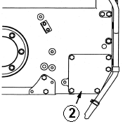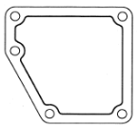 |  |  |  |  |  |  |  | 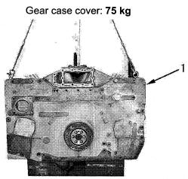  2
 |  | Front Seal | - Check front seal specification  - Press in the front seal uniformly so that it  is not at an angle. |  |  | STD or  OVER SIZE  S = Single Lip Seal  W= Double Lip Seal |  |  |  |  | 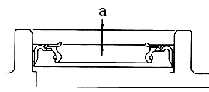  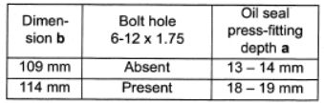
  S/W | STD | OS
9 | Flywheel  Housing | assembly | - No crack and no damage  - No damage thread hole  - Coat with gasket sealant(Three bond 1215 spec) then raise housing and install  - Coat mounting bolt with engine oil  SAE15W~40  - Tighten the flywheel housing mounting  bolts in order from diagram. Oil bolt  threads. |  |  |  |  |  |  |  | 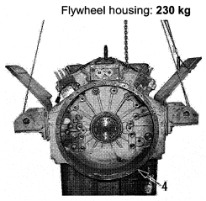  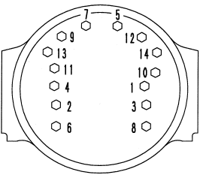
 |  |  | 1st step: Act : kgm |  |  | 35± 5 kgm
 |  |  | 2nd step: |  |  | Loosen it
 |  |  | 3rd step: Act : kgm |  |  | 42± 2 kgm (Shop Manual Page. 50-20)
 |  | Rear Seal | - Make sure that the rear seal no pitting,  no scratch.  - Press fit the rear seal (1)by  using installation tool to obtain correct  position. Be careful not to damage the  seal when installing the housing. |  |  | STD or  OVER SIZE  S= Single Lip  W= Double Lips |  |  |  |  | 27.4 mm  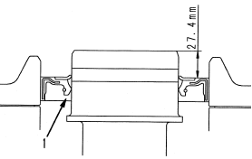  1  For New Crank shaft = 20mm
  S/W | STD | OS
No. | PARTS | CHECK | CONDITIONS TO BE CHECKED |  |  | SPEC. |  | SIGN |  |  | SKETCH DRAWING or PHOTOES
No. | PARTS | POINT |  |  |  |  |  | MEC | QA | SPV | SKETCH DRAWING or PHOTOES
10 | Supply pump Drive Case  Supply pump Assy |  | - Install supply pump drive case  - Install oil tube  * Install oil tube on the left bank alone. |  |  |  |  |  |  |  | 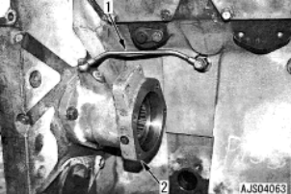
 | Supply pump Drive Case  Supply pump Assy |  | - Oil tube joint bolts :
11 | Supply pump Drive Case  Supply pump Assy |  | -Check all of Supplypump condition.  -Check torque lock nut of supplypump gear.  -Fit o ring to supply pump  -Mounting Supplypump& tighten mounting bolt  Act : kgm  S/N RH: kgm  S/N LH: kgm |  |  | 6.0~7.5 Kgm
  Act : kgm
  Supply Pump | New | Repaired
11 | Oil Pump Assy | Pump | - Check all of pump condition |  |  | ( Shop Manual Page. 00-32) |  |  |  |  | 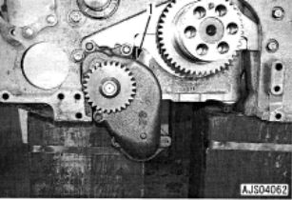  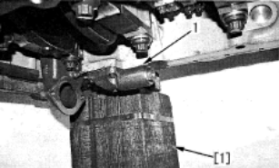  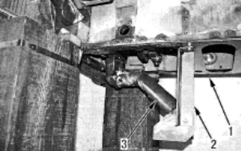
  Oil Pump | New | Reuse
 |  |  | - Fill in oil engine to inner of pump
 |  |  | - Rotate pump by hand smoothly
 |  |  | - Fit oring for sensor side
 |  |  | - Mounting oil pump and tighten mounting  bolts. |  |  | 10 ~ 12.5 kgm
 |  |  |  |  |  | ( Shop Manual Page. 00-32)
  Act : kgm
 |  | Main Relief Valve | - Recheck plug of main relief valve (retighten)
  Relief Valve | New | Reuse
 |  |  | - Fit oring and install discharge pipe |  |  | 6.0~7.5 Kgm
 |  |  |  |  |  | ( Shop Manual Page. 00-32)
  Act : kgm
12 | Oil Pan |  | - Recheck Condition 0f Oil Pan  (No crack , No band and No damage)  - Install the gasket and push up oil pan  with a pallet lift, etc. and tighten the  mounting bolts  - Connect the level sensor connector.  - When tightening, start from center and work in order to the out side. |  |  |  |  |  |  |  | 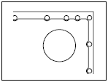  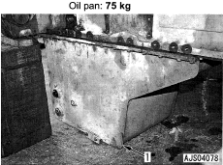
  Oil Pan | New | Reuse
 |  |  | - Tighten mounting bolts. |  |  | 6.0~7.5 Kgm  ( Shop Manual Page. 00-32)
  Act : kgm
13 | Front Suport |  | - Prior to the installation, fill the oil hole with  Grease. |  |  | STD Grease :  (G2-LI) |  |  |  |  | 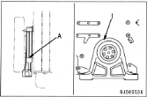  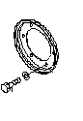  A
 | Front Suport |  | - Volume of grease filled : 20 cc
 | Front Suport |  | - Tighten mounting bolts cover ( A )
 | Front Suport |  |  |  |  | 10 ~ 12.5 Kgm  ( Shop Manual Page. 00-32)
  Act : kgm
No. | PARTS | CHECK | CONDITIONS TO BE CHECKED |  |  | SPEC. |  | SIGN |  |  | SKETCH DRAWING or PHOTOES
No. | PARTS | POINT |  |  |  |  |  | MEC | QA | SPV | SKETCH DRAWING or PHOTOES
14 | Dumper and Crank Pulley Ass’y | Damper | - Lift and install damper and crank pulley  assembly,  * Install the assembly aligning it to the  dowel pin of the crankshaft.  - Coat mounting bolts and washer with  engine oil SAE15W40  - Tightening Mounting bolt: |  |  | 10 ~ 12.5 kgm  (Shop Manual page. 50-19) |  |  |  |  | 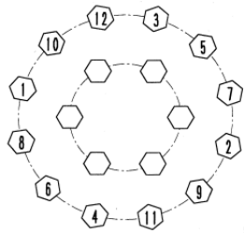
  Act : kgm
15 | Dumper and Crank Pulley Ass’y  Cont. | Damper | - Tighten the mounting bolts in 3 steps  according to the order indicated in the  figure.  - Coat mounting bolts and washer with  engine oil SAE15W40  - Tightening Mounting bolt: |  |  | (Shop Manual page. 50-19) |  |  |  |  | 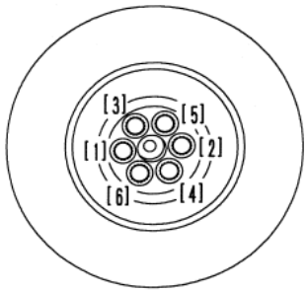
  Step 1st | Act : kgm
  Step 2nd | Act : kgm
  Step 3rd | Act : kgm
  7.5 ± 2 Kgm
  25 ± 2 Kgm
  76 ± 2 Kgm
16 | Flywheel |  | -Using eye bolt  @ (Dia. = 12 mm, Pitch = 1.75 mm),  -Sling flywheel , install the flywheel to the  crankshaft,  -Coat the threads of the bolts and the  seat face, with engine oil 15W40  * Make a punch mark on the bolt head each time the bolts are used.  Fly wheel mounting bolts : |  |  | (Shop Manual page. 50-23) |  |  |  |  | 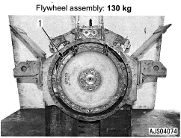  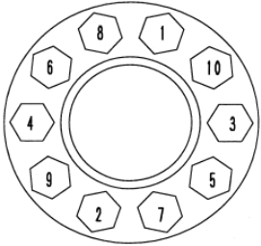
  Step 1st | Act : kgm
  Step 2nd | Act : kgm
  Step 3rd | Act : kgm
  10 ± 2 Kgm
  30 ± 2 Kgm
  55 ± 2 Kgm
17 | Cam  Follower | assembly | - Before installing the cam follower ass’y, |  |  | 4.5 ~ 6.0 kgm  (Shop Manual page. 50-13)  3.5 ~ 4.5 Kgm  ( Shop Manual Page. 50-13) |  |  |  |  | 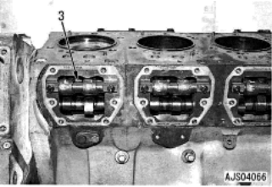  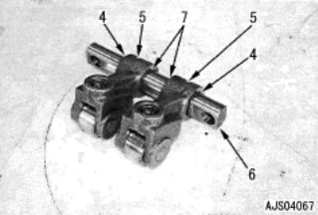
 | Cam  Follower |  | Wash the oil hole of the mounting bolt.
 | Cam  Follower |  | - Make sure that the oil hole is free from  dirt.
- Use LG-6 liquid gasket on the cover face.
(Use Three bond 1215 spec)
 |  | Torque | - Cam follower mounting bolt .
  Act : kgm
 |  |  | - Cam follower cover mounting bolts.
  Act : kgm
No. | PARTS | CHECK | CONDITIONS TO BE CHECKED |  |  | SPEC. |  | SIGN |  |  | SKETCH DRAWING or PHOTOES
No. | PARTS | POINT |  |  |  |  |  | MEC | QA | SPV | SKETCH DRAWING or PHOTOES
18 | Oil Cooler Ass’y |  | - Check that there is no dust or dirt inside  the oil cooler and no crack  - Fit gasket and install oil cooler assembly  - Oil Cooler mounting bolt:  -Use gasket sealant Three bond 1215 spec. |  |  | (M10) Bolts :  6.0 ~ 7.5 Kgm (Shop Manual page. 00-32) |  |  |  |  | 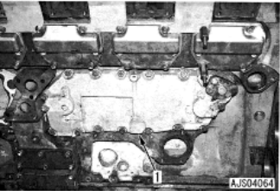
  Oil cooler | New | Reuse
  Front Side
  Rear Side
  Act : kgm
19 | Common Rail |  | - Install Bracket (3)  - Install common rail (2)  -Common rail mounting bolts :  * Install the common rail at this point  since positioning af the high-pressure  pipe needed when installing the fuel  injector. |  |  | 4 ~ 5 kgm  ( Shop Manual Page. 50-26) |  |  |  |  | 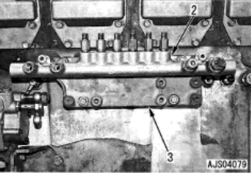
  Act : kgm
20 | Cylinder |  | - Check that there is no dust or dirt inside the cylinder and on mounting surface.  - When installing the gasket, check that the  grommet has been fitted and has not  come  - The grommets in the head gasket may become deformed by swelling, so do not coat them with gasket sealant.  - Check and mark grommet with white marker. |  |  |  |  |  |  |  | 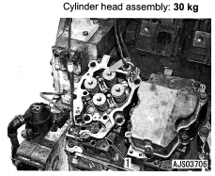
  Cyl. | 1 | 2 | 3 | 4 | 5 | 6
  RH
  LH
 | Head
 |  | Grommets
 |  | O/S head  gasket | If oversize head gaskets are to be fitted, the block must be stamped O/S. |  |  | STD or OVER SIZE |  |  |  |  | 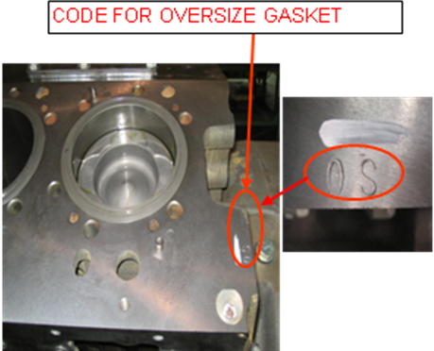  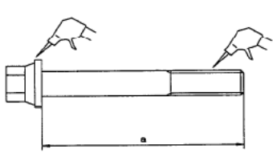  a
  STD | OS
 |  | Bolts | -The head bolts must have no dirt in the  threads or under the washer, or in the  threaded holes in the block. |  |  | limit length (a) :  Short bolt =  Less than 170.8 mm  Long bolt =  Less than 205.8 mm
 |  |  | -Coat the thread and bolt head with Oil.
 |  |  | The threaded holes in the block must be free from dirt. A tap can be used to clean the threads
No. | PARTS | CHECK | CONDITIONS TO BE CHECKED |  |  | SPEC. |  | SIGN |  |  | SKETCH DRAWING or PHOTOES
No. | PARTS | POINT |  |  |  |  |  | MEC | QA | SPV | SKETCH DRAWING or PHOTOES
 | Cylinder  Head  Cont. | Torque | - Install cyl. head gasket.  - Lift cy. Head ass’y then install to the block  -Recheck bahwa marking nomor di Cyl.Head housing sesuai dgn urutan  Pada Cylinder block.  - Tighten Cyl. head mounting bolt .  * No.1- 6 : |  |  |  |  |  |  |  | 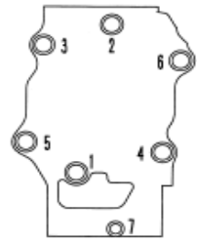  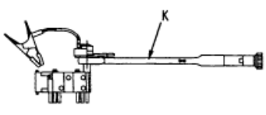  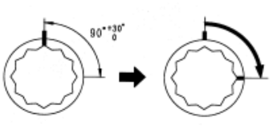
  Step 1st | Act : kgm
  Step 2nd | Act : kgm
  Step 3rd | Act : kgm
  14 ~ 16 Kgm
  29 ~30 Kgm
  90 ~ 120 ⁰
 | Cylinder  Head  Cont. |  |  |  |  | ( Shop Manual Page. 50-27)
 |  |  | * No.7 :  Torque in the order shown.  - After tightening, make a punch mark on  the bolt head. If the bolt has 5 marks, do  not use it. Replace it with new one. |  |  | 6.75 ± 0.75 kgm  ( Shop Manual Page. 50-27)
  Act : kgm
 |  |  | - Install the water tube.  Water tube joint bolts : |  |  | ‘  1.0 ~ 1.3 Kgm  ( Shop Manual Page. 50-28)
  Act : kgm
 |  |  | - Install heat label at cylinder head No.6 |  |  | 99°c ~ 127°c (210°F ~ 260°F)
  Act : °
21 | Valve Mec-hanism | Cross  Heads | - Fit cross heads and adjust so that |  |  | 6.0 ± 0.6Kgm  ( Shop Manual Page. 50-28) |  |  |  |  | 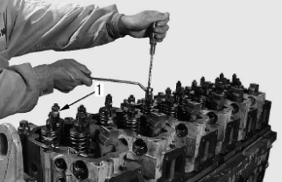
 | Valve Mec-hanism |  | when the screw has touched the valve  stem it is advanced 20°.
- Cross head adjusting screws go to
exhaust manifold side of head.
- Lock nut tighten torque:
Act : kgm

 |  | Push rod | - Install Push rod in the hole  * Check that the push rod is in the cam follower.
 |  | Fuel injector | - Check that the inside of the injector  Sleeve is free from dirt.  *O-ring : coat with Engine oil  *Ball washer: coat with Engine oil  -Holder mounting bolt:  Act = kgm  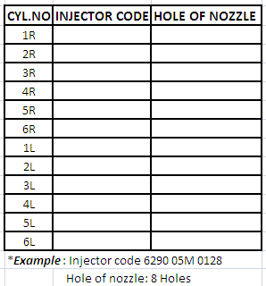 |  |  | 6.0 ~ 7.5 kgm ( Shop Manual Page. 50-28) |  |  |  |  | 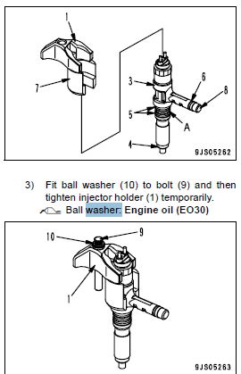
  Write injectors code below:
 |  | Common rail and high-pressure pipe | - Before installing the high-pressure  pipe, check it for the following defects.  If there is any of these defects, it can  cause fuel leakage. Accordingly,  replace the high-pressure pipe. |  |  |  |  |  |  |  | 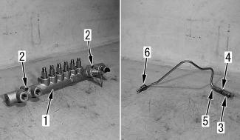
No. | PARTS | CHECK | CONDITIONS TO BE CHECKED |  |  | SPEC. |  | SIGN |  |  | SKETCH DRAWING or PHOTOES
No. | PARTS | POINT |  |  |  |  |  | MEC | QA | SPV | SKETCH DRAWING or PHOTOES
 |  | Torque | - Tighten special bolts (2) :  - Tighten Sleeve Nut (5)(6) :  - Tighten Clamp : |  |  | 6.02 ~ 7.55kgm  ( Shop Manual Page. 50-16)  4 ~ 5 kgm  ( Shop Manual Page. 50-17)  1.0 ± 0.1 kgm  ( Shop Manual Page. 50-17)
  Act : kgm
  Act : kgm
  Act : kgm
 |  | Rocker Arm and Shaft Ass’y | -Install rocker arm and shaft assembly (1) and  -tighten mounting bolts (2), (3) and (4). |  |  |  |  |  |  |  | 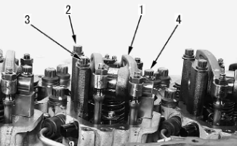
 |  | Rocker Arm and Shaft Ass’y | *Before tightening the mounting bolts,  check that the ball of the adjustment  screw is fitted to the socket of the push  rod.
 |  | Rocker Arm and Shaft Ass’y | - TightenTorque mounting bolts. |  |  | 9.5 ~10.5 kgm  ( Shop Manual Page. 50-17 )
 |  | Rocker Arm and Shaft Ass’y
  Act : kgm
 |  | AdjustingValve clereance | -Adjust valve clereance  Intake : |  |  | 0.35 ± 0.02  ( Shop Manual Page. 13-39 ) |  |  |  |  | 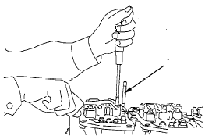  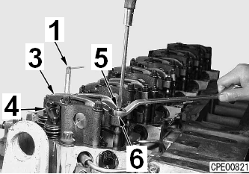  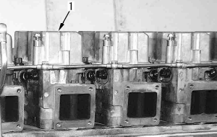
  Act : mm
 |  |  | -Adjust valve clereance.  Exhaust : |  |  | 0.57 ± 0.02  ( Shop Manual Page. 50-17 )
  Act : mm
 |  |  | -Tighten locknut (6) to secure adjustment  screw (5)  -Locknut: |  |  | 5.4 ~6.6 kgm  ( Shop Manual Page. 50-18 )
  Act : kgm
 |  | Head cover | -Fit the O-ring and install cylinder head cover.  -Since the bolt at the front on the air intake  manifold side is also used to secure the  wiring harness clamp, tighten it  temporarily.  -Mounting bolt:
  Act : kgm
3.0 ~ 3.5 kgm
( Shop Manual Page. 50-18)

18 | Wiring Harness &  Sensor Con-nector |  | - Install wiring harness terminal (6) to  fuel injector (5) and tighten 2 nuts (7  - Terminal nut tighten torque:  - Install sensor connector |  |  | 0.2 ± 0.02 kgm  (Shop Manual page. 50-22) |  |  |  |  | 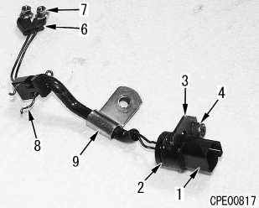
  Act : kgm
No. | PARTS | CHECK | CONDITIONS TO BE CHECKED |  |  | SPEC. |  | SIGN |  |  | SKETCH DRAWING or PHOTOES
No. | PARTS | POINT |  |  |  |  |  | MEC | QA | SPV | SKETCH DRAWING or PHOTOES
19 | EGR Pump Ass’y |  | - Install EGR pump assembly |  |  |  |  |  |  |  | 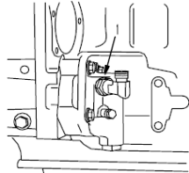
20 | Piping & wiring of supply pump |  | - Install bracket (1).  - install fuel tubes (2) and (3).  Sleeve nut of tube :  • Pump side  • Common rail side  Clamping bolt :  - Install fuel tubes (7) and (8).  • Pump side  •Common rail side  - Install Oil tubes (9) (10) and (11).  • Joint bolt of tubes (9) and (10).  • Sleeve nut of tube (11)  - Mounting bolt of clamps (14), (15)  and (16):  -Supply pump assy S/N:  RH:  LH: |  |  | 4 ~ 5 kgm  (Shop Manual page. 50-23)  4 ~ 6 kgm  (Shop Manual page. 50-23)  1.0 ± 0.1 kgm  (Shop Manual page. 50-23)  1.5 ~ 2.0 kgm  (Shop Manual page. 50-23)  1.8 ~ 2.3 kgm  (Shop Manual page. 50-23)  0.8 ~ 1.3 kgm  (Shop Manual page. 50-23)  4.4 ~4.8 kgm  (Shop Manual page. 50-23)  0.8 ~ 1.3 kgm  (Shop Manual page. 50-23) |  |  |  |  | 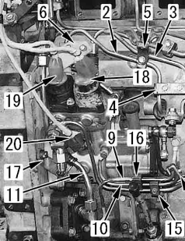  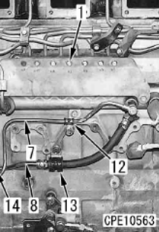
  Act : kgm
  Act : kgm
  Act : kgm
  Act : kgm
  Act : kgm
  Act : kgm
  Act : kgm
  Act : kgm
 |  | 1 | -Mounting Lock Bolt on Fuel pump drive  RH and LH and install the washer gasket.  Act: kgm  (after finish install fuel pump assy to fuel  Pump drive). |  |  | 0.8 ~ 1.2 kgm  (Shop Manual page. 50-23) |  |  |  |  | 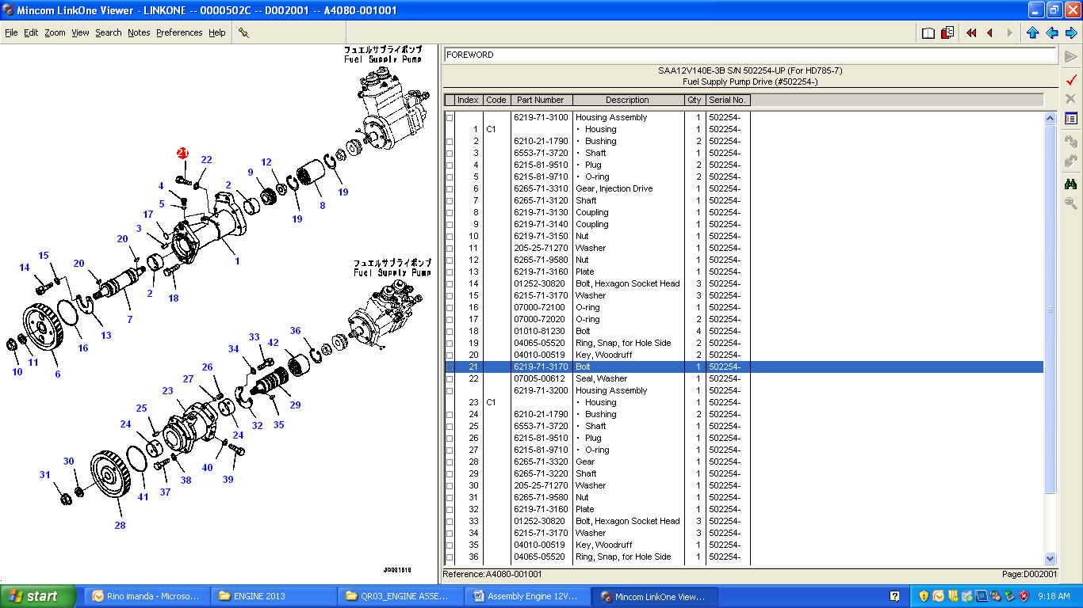
21 | Breather remote tube and corrosion resistor  tube |  | - Install breather remote tube (3).  - Install corrosion resistor tubes (2) and (1)  temporarily |  |  |  |  |  |  |  | 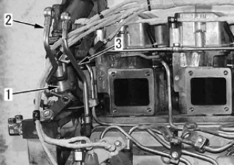
22 | Engine controller cooler |  | - Install the O-ring and plate (1).  - Install engine controller cooler (2) and fuel  hose (3)  *Install the hose on the engine controller  cooler inlet side when installing the  fuel filter head.  - Cooling plate mounting bolt:  - Connect fuel pressure sensor connector  PFUEL (4) and engine oil pressure sensor  connector POIL (5) |  |  | 3.5 ~ 4 kgm  (Shop Manual page. 50-32) |  |  |  |  | 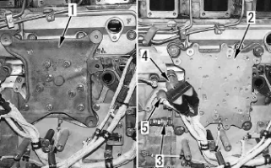
  Act : kgm
No. | PARTS | CHECK | CONDITIONS TO BE CHECKED |  |  | SPEC. |  | SIGN |  |  | SKETCH DRAWING or PHOTOES
No. | PARTS | POINT |  |  |  |  |  | MEC | QA | SPV | SKETCH DRAWING or PHOTOES
23 | Engine controller |  | - Install engine controller (2) and connect  connector (1).  -Engine controller S/N:  RH:  LH: |  |  |  |  |  |  |  | 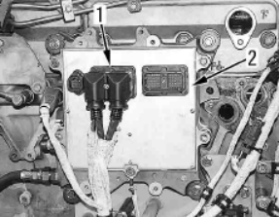
24 | Air Intake Manifold |  | - Fit the gasket and sling and install air  intake manifold (1) and then tighten the  mounting bolts in the following order.  - Mounting bolt: |  |  | 6.0 ~7.5 kgm  ( Shop Manual Page. 50-32 ) |  |  |  |  | 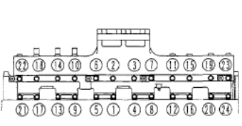
 | Air Intake Manifold |  | - Install air intake connector.
  Act : kgm
26 | Water Pump |  | -Fit O-ring and install water pump assembly  * The mounting bolts of the water pump  are used to tighten the gear case.  Tightening Mounting bolt: |  |  | 9,5 ~ 10,5 Kgm (Shop Manual page. 00-32) |  |  |  |  | 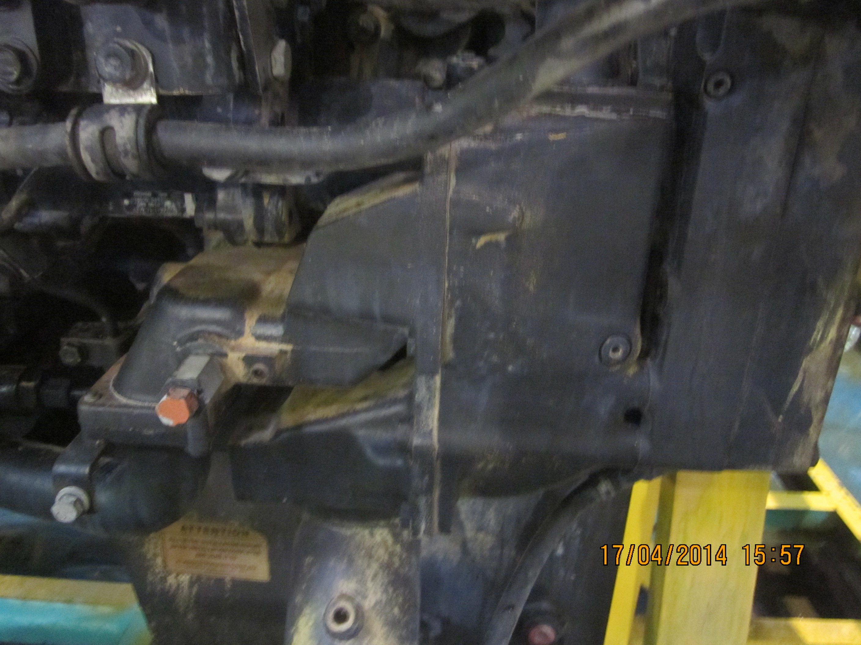
  Water Pump | New | Reuse
  Act : kgm
27 | Thermo-stat housing |  | -Fit O-ring to tube (21, then install to  thermostat housing (4).  -Fit gasket and install thermostat housing (4)  with mounting bolts (3).  -Move tube (2) down and install ring (I).  Tightening Mounting bolt: |  |  | 6.7± 0.7 Kgm (Shop Manual page. 00-32) |  |  |  |  | 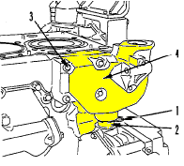
  Act : kgm
28 | Exhaust  manifold  & Turbo Charger | Exhaust  manifold | - Fit the gasket and sling and install  exhaust manifold and then tighten the mounting bolts in the following order  - Mounting bolt: |  |  | 6.0 ~7.5 Kgm  ( Shop Manual Page. 50-27) |  |  |  |  | 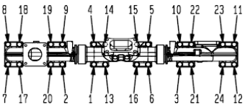  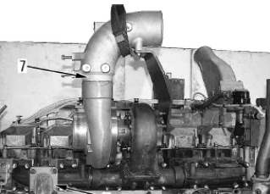
 | Exhaust  manifold  & Turbo Charger | Exhaust  manifold
  Act : kgm
 | Exhaust  manifold  & Turbo Charger | Turbo Charger | - Fit the gasket and install turbocharger  assembly |  |  | 4.5~5.0 Kgm  ( Shop Manual Page. 13-51)
 | Exhaust  manifold  & Turbo Charger | Turbo Charger | - Turbo charger mounting bolt torque :
  Act : kgm
 | Exhaust  manifold  & Turbo Charger | Turbo Charger | -Turbocharger assy S/N:  RH:  LH:  -Fill oil to Turbocharger oil inlet for pre Lubricating when engine first running in Dyno(until fully on oil inlet hole)
No. | PARTS | CHECK | CONDITIONS TO BE CHECKED |  |  | SPEC. |  | SIGN |  |  | SKETCH DRAWING or PHOTOES
No. | PARTS | POINT |  |  |  |  |  | MEC | QA | SPV | SKETCH DRAWING or PHOTOES
29 | Starting Motor |  | - Fit the gasket and install starting  motor assembly (4) with bolts (3)  - Install wiring harness terminal B (1) and  connector terminal R (2).  mounting bolt torque:  -Starting motor assy S/N:  Upper:  Lower: |  |  | 20 Kgm  ( Reman  Standard ) |  |  |  |  | 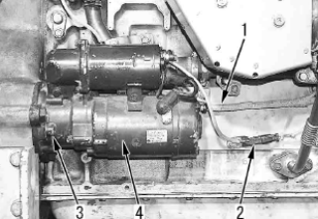
  Act : kgm

Carry out a visual inspection of the engine prior to dyno testing

Tightening Torque for Sensor |  |  | Notes :
Sensor name | Tightening torque |  | Notes :
NE | 4.9 – 7.9 Nm {0.5 – 0.8 kgm}
Engine speed | 69 – 74 Nm{7 – 7.5 kgm} (Locknut)
Fuel temperature | 23 ± 3 Nm {2.35 ± 0.3 kgm}
Boost pressure | 23 ± 3 Nm {2.35 ± 0.3 kgm}
Intake air temperature | 23 ± 3 Nm {2.35 ± 0.3 kgm}
Coolant temperature | 23 ± 3 Nm {2.35 ± 0.3 kgm}
EGR gas pressure | 23 ± 3 Nm {2.35 ± 0.3 kgm}
Engine oil pressure | 23 ± 3 Nm {2.35 ± 0.3 kgm}
Atmospheric pressure | 7.3 – 12.7 Nm {0.7 – 1.3 kgm}  (Hexagon head bolt)  4.1 – 9.5 Nm {0.4 – 1.0 kgm}  (Hexagon socket head bolt)
Fuel pressure | Never disassemble.
ASSEMBLY BY | INSPECTED & APPROVED BY

MECHANIC (MEC) |  | QUALITY ASSURANCE (QA) |  | PROD. SUPERVISOR (SPV)

